Beginner Training Program – Muscular Endurance & Strength
You should consult your physician or health care provider before starting any exercise program, especially if you have pre-existing injuries or physical conditions.
Description:
This 12-week training program is designed for beginners to increase muscular endurance and overall strength by using cable and weight machines. These machines are easy to operate, contain a fixed range of motion, allow for gradual weight increases and has the ability to target specific muscle groups. Depending on availability, participants may choose from the 2-day per week program or the 3-day per week program.
Physical Activity Readiness Questionnaire
- Has your doctor ever said that you have a heart condition and that you should only do physical activity recommended by a doctor?
- Do you feel pain in your chest when you do physical activity?
- In the past month, have you had chest pain when you were not doing physical activity?
- Do you lose your balance because of dizziness or do you ever lose consciousness?
- Do you have a bone or joint problem (for example, back, knee or hip) that could be made worse by a change in your physical activity?
- Is your doctor currently prescribing drugs (for example, water pills) for your blood pressure or heart condition?
- Do you know of any other reason why you should not do physical activity?
If you answered yes to one or more of these questions, please consult with your doctor prior to becoming physically active.
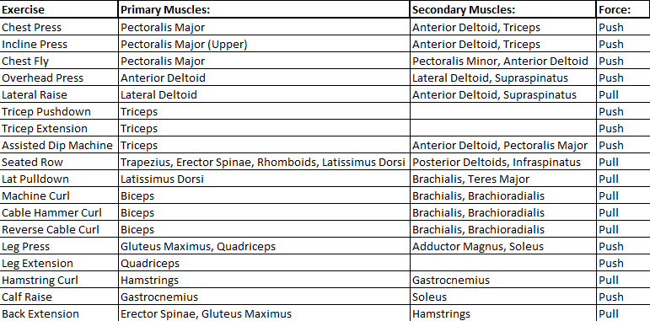
Exercises and Muscles Worked:

Warm-Up and Stretch:
Benefits of Warm-Up: Increased heart and respiratory rate, increased tissue temperature, and increased psychological preparation for bouts of exercise.
Benefits of Stretching: Increased range of motion, helps prevent injuries, improves posture, and can help relieve stress.
The Warm-Up:
5 minutes of low-intensity work on the treadmill, exercise bike, or elliptical.
The Stretches:
- Knee to Chest – 5 Each Leg
- Leg Swings – 5 Each Leg
- Standing Glute Stretch – 5 Each Leg
- Side-to-Side Lunge – 5 Each Leg
- Hip Openers – 5 Each Side
- Cross Body Arm Swings – 10
- Arm Circles – 5 Each Arm
Lifting:
Position and Movement:
Instructions are included on each machine that demonstrate how to place yourself on the machine to properly execute each movement.

Finding the Right Weight:
For our muscles to adapt and grow stronger, we have to challenge ourselves by finding a weight that is heavy enough to do so. However, if we choose a weight that is too heavy, it starts to compromise our form and can lead to engaging incorrect muscle groups and/or injury.
It will take trial and error to find the right starting weight, but here are a couple tips to help:
The weight you choose should make your last few reps challenging, without compromising your form. For example, in the first week of this program the repetitions range is 12-15 reps. You want to find a weight where at that 12th repetition it starts to get more challenging. If you make it to 15 repetitions easily and without strain, that is probably a good indicator to increase your weight slightly next round. And for the opposite, if you can’t make it to the 12th repetition then you should lower your weight some.

2 Day Split Program
First 4 Weeks
Day 1

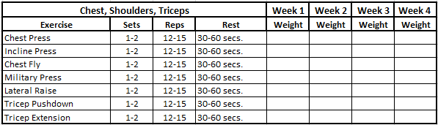

Day 2
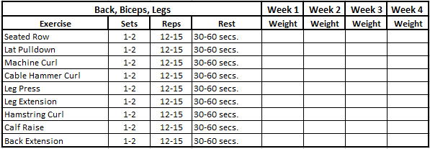
Second 4 Weeks
Day 1

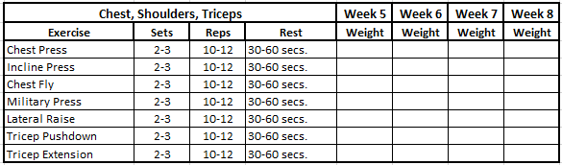

Day 2
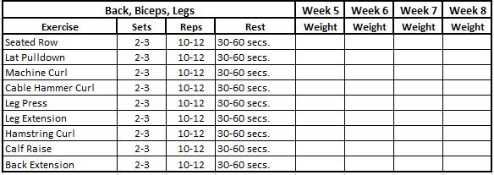

Last 4 Weeks
Day 1

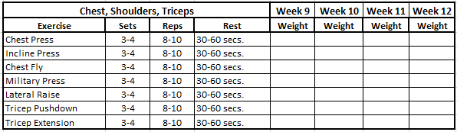

Day 2
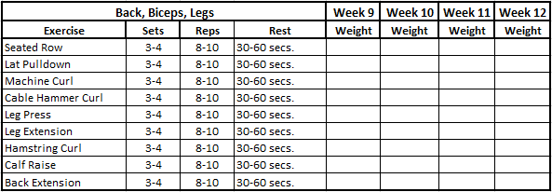

3 Day Split Program
First 4 Weeks
Day 1

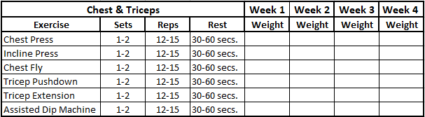

Day 2

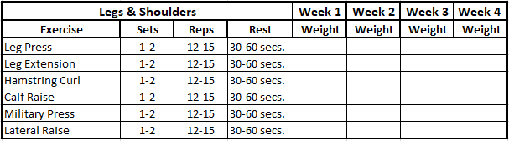

Day 3

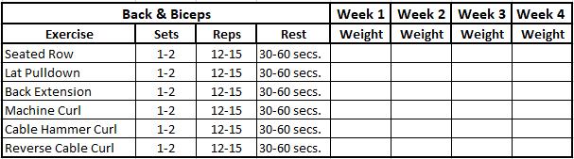

Second 4 Weeks
Day 1

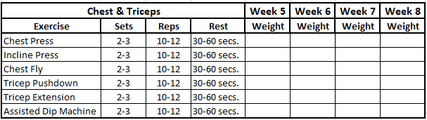

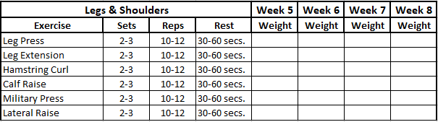
Day 2

Day 3

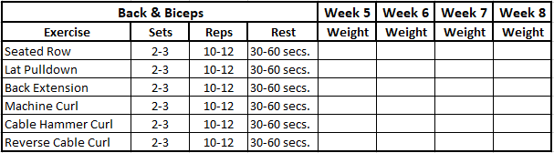

Last 4 Weeks
Day 1

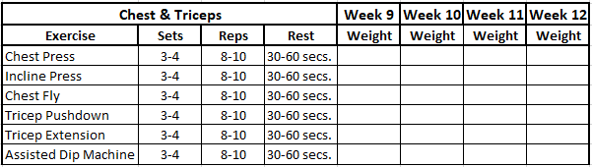

Day 2

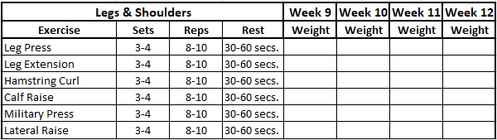

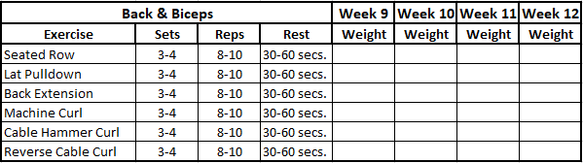
Day 3

Core and Cool Down:
Benefits of Core Exercises: Balanced core muscles help maintain appropriate posture and reduce strain on the spine
Benefits of a Cool Down: Helps lower chance of injury, promotes blood flow, and helps bring heart rate, body temperature, and blood pressure levels back to their normal levels before carrying on with your everyday activities.
Core:
2 Rounds
- Plank – 30 Seconds
- Side Plank – 30 Seconds Each Side
- Bird Dogs – 30 Seconds
- Dead Bugs – 30 Seconds
Cool Down:
5 Minutes of low intensity cardio on treadmill, exercise bike, or elliptical
Static Stretches: 20 second hold on each
- Abdominal Stretch
- Hip Flexor Stretch
- Lower Back Stretch
- Standing Forward Bend
- Quad Stretch
- Calf Stretch
- Shoulder Stretch
- Child’s Pose
Nutrition:
Proper nutrition is a very important aspect of an exercise program. Consuming the necessary nutrients will only aide in the building of muscular strength and endurance. So here are a few resources to help get a better understanding:
- Healthy Eating | American Heart Association
- MyPlate | U.S. Department of Agriculture
- 6 Essential Nutrients: What They Are and Why You Need Them (healthline.com)

Videos:
Videos for warm-up stretches, use of each machine, core exercises and cool down stretches will all be linked to the Fitness Center webpage.
Training Program Videos - Santa Fe College Athletics (santafesaints.com)

